Sprint 2 – Accuracy Design Document

November 25, 2020

Table of Contents
1. Executive Summary 3
1.1 Project Overview 3
1.2 Purpose and Scope of this Specification 3
2. Product/Service Description 3
2.1 Product Context 3
2.2 User Characteristics 3
2.3 Assumptions 3
2.4 Constraints 3
2.5 Dependencies 4
3. Requirements 4
3.1 Functional Requirements 5
3.2 Security 5
3.2.1 Protection 5
3.2.2 Authorization and Authentication 6
3.3 Portability 6
4. Requirements Confirmation/Stakeholder sign-off 6
5. System Design 6
5.1 Algorithm 6
5.2 System Flow 6
5.3 Software 6
5.4 Hardware 6
5.5 Test Plan 7
5.6 Task List/Gantt Chart 7
5.7 Staffing Plan 7

Executive Summary

Project Overview

The main objective of this project is to successfully problem solve, quantify, organize, document, code, test, and present a software system. The intended robot project will be completed with clear instructions for the following performance tests: Endurance, Accuracy, and Agility. Sprint 2 will be focusing on Accuracy

Purpose and Scope of this Specification
The purpose of this specification is to allow children, adults, students, and professors to use the robot in its intended conditions (smooth and flat surfaces). This robot can be used for educational purposes as well as just playing around the house. In this sprint, we will be focusing on the accuracy of the robot and its program. This will be tested through a figure eight course.

In scope
-The robot and its program is intended for inside use only
- The robot and its program requires a smooth flat surface
- The robot and its program requires large enough space to successfully run the program

Out of Scope
- The robot and its program is not intended to be used on rough or bumpy surfaces
- Operating on these surfaces can result in damage to the robot.
- Outside elements can also cause damage to the robot and could cause it to not run properly

Product/Service Description

Product Context
This is the second test of the Robotics Triathlon project which consists of one more test which will test endurance of the robot and its program.

User Characteristics
Users of this robot may consist of students, faculty, staff, individuals with previous coding experience or technical expertise. In order to use the robot, users simply need to understand simple block coding via the Sphero App. Access to a device with Bluetooth is required in order to successfully connect to the robot via the Sphero App.

Assumptions
- The robot and its program will only work on certain operating systems
- iOS, Android, Fire OS, Windows, Chrome, and macOS
- Access to a flat, indoor surface that was able to meet the required measurements

Constraints
- Not all members had access to the robot
- COVID-19 limited our opportunities to meet in person
- Some members of the group work full time/part time jobs
- Members weren’t able to use room with official measurements on campus

Dependencies
- Robot must follow the correct path
- This project is dependent on that robot following the correct path
- If not, it will not succeed the intended goal/path
- Code must be established
- SpheroSPRK+ must be charged every hour

Requirements

Functional Requirements
Req# | Requirement | Comments | Priority | Date Rvwd | SME Reviewed / Approved
ACCUR_01 | Robot must stay within the path. | The robot cannot go off the path, it must stay within the path and finish the tasks within. | 1 | 11/22/20 | Approved
ACCUR_02 | Robot must successfully run the figure eight course 5 times. | Robot has to go around the path only five times no more no less. | 2 | 11/22/20 | Approved
ACCUR_03 | Robot must finish at the place where it had started | Robot should do the tasks provided when finished go back to the place where it first started. | 3 | 11/22/20 | Approved
ACCUR_04 | Robot should speak “I am the winner”. | When robot is done moving around it should speak what is coded to them. | 4 | 11/22/20 | Approved
ACCUR_05 | Robot should flash multicolored lights for 5 seconds. | When robot is speaking it should also flash multicolored lights for only 5 seconds. | 5 | 11/22/20 | Approved
ACCUR_05 | Robot should be able to start and move as task are provided | Robot should not stay in the same place and be able to move and do the task provided. | 6 | 11/22/20 | Approved
ACCUR_05 | Making sure robot does do the tasks but at a steady pace | It does not go to fast which messes up what it’s doing and changes its path. | 7 | 11/22/20 | Approved
ACCUR_05 | Making sure the path is accurate to the one provided in the video | The Figure-Eight measurements should be the same as the video provided on E-campus | 8 | 11/22/20 | Approved

Security

Protection
The code will be developed in the app Sphero.Edu and it will be listed as private which means no one will be able to view the code except the one who has access to the account. The code is private and shared among the people within the group where they have their accounts on private with code as well-being private. To access GitHub with the files of our project, only people with the link will have the access. The only ones with the link are the professor and the group. The group is the only one who is allowed to add, delete, review files because the collaborator has invited them and only them to access.

Authorization and Authentication
The only person who is allowed to view and/or access the coding is the one who has the Sphero.Edu username and password. This account is strictly for coding group projects in which the coding is listed private and no one can view it accept the ones who are given access. When it comes to GitHub, the collaborator has to invite others to edit, view, and add files. The only people given invitation are the members within the group

Portability
- One member has access to the code which is made on Spehor.Edu but the member has shared the coding among the individuals
- 60 Percentage of code is being done by one member while the other member does 40 percent. When developing the code, the partners work together to figure it out

Requirements Confirmation/Stakeholder sign-off
Include documentation of the approval or confirmation of the requirements here. For example:
Meeting Date | Attendees (name and role) | Comments
11/18/2020 | Michael Auletto: Develop Code, Test Code  Jamir Barnes: Complete second part Design Doc  Christian Dimitry: Complete first part Design Doc  Haemah Akhtar: Complete last part Design Doc | Tasks were provided to each team member and deadline was set for when to finish these specific tasks.

System Design

Algorithm
Develop and describe here the algorithm that will be used to provide the required performance of your software

- Turn Sphero on by either shaking or double tapping
- Connect the Sphero to the app Sphero.Edu through Bluetooth to a computer
- Sphero will be put on the ground between the two circles
- Turn Stabilization on
- Head 0 degrees on speed 40
- Spin 360 for 10 seconds
- Spin -360 for 10 seconds
- Stop
- Speak “I am the winner.” And wait
- Fade from red to pink over 1 seconds
- Fade from pink to blue over 1 seconds
- Fade from blue to cyan over 1 seconds
- Fade from green to green over 1 seconds
- Fade from yellow to orange over 1 seconds
- Stop Program
- Exit program
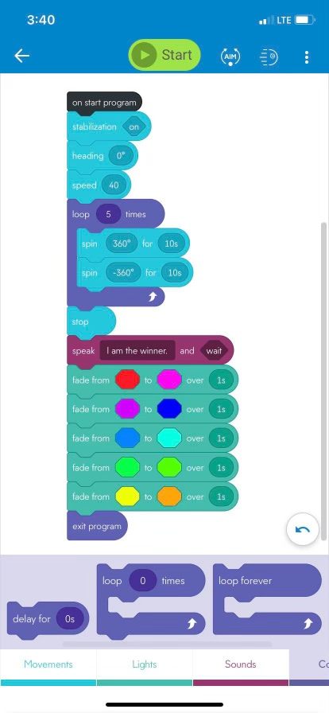
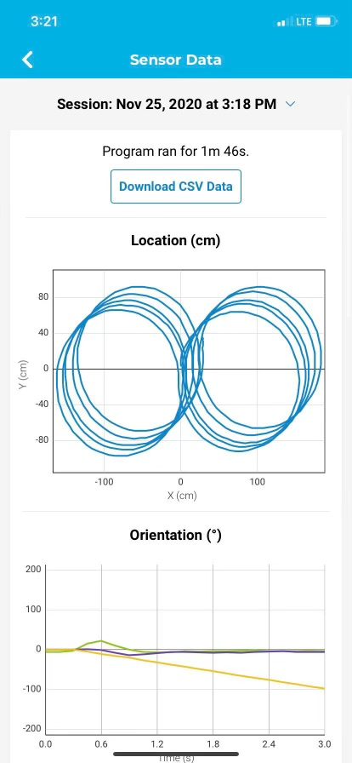

System Flow
Develop a flowchart (and show here) that accurately depicts how your software application will act to fulfill the algorithm
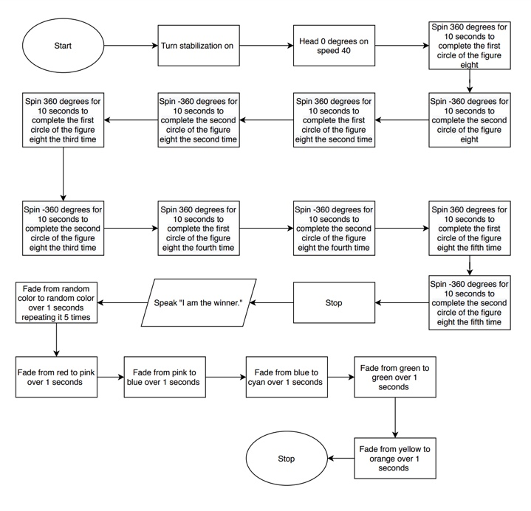

Software
The software that are being used is the app Sphero.Edu that has been downloaded on the MacBook and Windows computer. On this app JavaScript is being used, there is block coding occurring to develop a program for the robot. To test the block code on the robot, Bluetooth is able to connect the devices.

Hardware
The Hardware being used is the computer (MacBook and Windows Desktop). The computer allows one to develop the coding on the app. The coding is tested on the robot which will be connected through Bluetooth which will connect the robot to the computer.

Test Plan

Reason for Test Case | Test Date | Expected Output | Observed Output | Staff Name | Pass/Fail
Robot is able to speak and change its color. | 11/23/20 | Robot should speak ‘I am the winner’ and should flash multicolored lights. | Robot successfully spoke and changed its colors as coded for it to do so. | Michael Auletto | Pass
Robot should stay within the path provided. | 11/23/20 | Robot should stay within the figure eight course. | Robot goes off the course and does the task provided in the wrong direction. | Michael Auletto | Fail
Robot should stay within the path provided. | 11/23/20 | Robot should stay within the figure eight course after changing the degrees. | Robot is able to stay on the path. | Michael Auletto, Haemah Akhtar | Pass
Robot should successfully run the course 5 times. | 11/23/20 | Robot should be able to run the course 5 times and no more. | Robot only runs it four times. | Michael Auletto, Haemah Akhtar | Fail
Robot should successfully run the course 5 times. | 11/23/20 | Robot should be able to run the course only 5 times no less no more. | Robot is successfully able to run the course 5 times without any issues after developing the coding. | Michael Auletto, Haemah Akhtar | Pass
Robot should start and finish at the same path. | 11/23/20 | When finish with the task provided the robot should stop at the same square spot where it first started. | Robot is able to successfully run the course and come back to the same square where it started. | Michael Auletto | Pass
Robot goes on a steady pace | 11/23/20 | Robot should not go to fast where it goes out of balance | Robot goes on a steady pace | Michael Auletto | Pass
The Degree would be able to work along with the robot | 11/23/20 | Making sure the Degrees put in for the task will work | The degree does not help the robot do its task properly | Michael Auletto | Fail
Making new degree to make sure the robot functions properly | 11/23/20 | The robot should have a particular degree it is on to make sure it goes on the right path | Robot is able to work properly with the speed and degrees | Michael Auletto, Haemah Akhtar | Pass

Task List/Gantt Chart
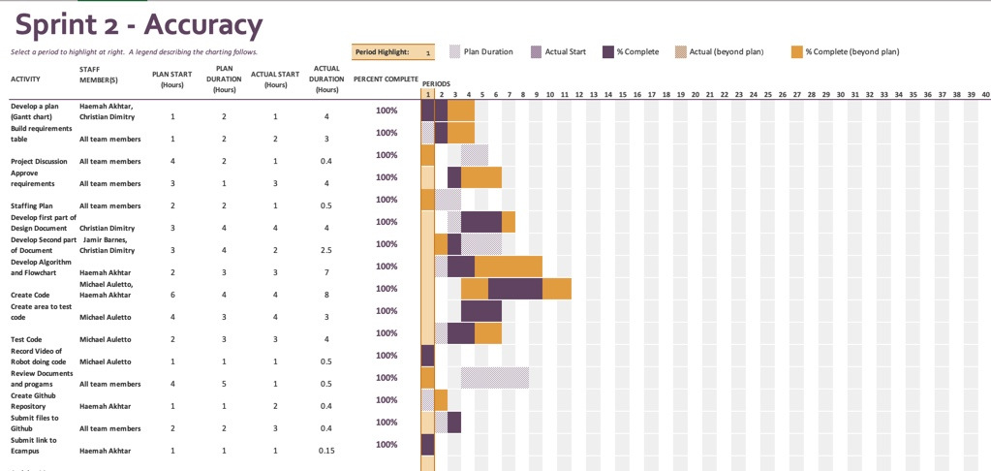

Staffing Plan

Name | Role | Responsibility | Reports To
Jamir Barnes | Develop Document | Develop second part of the document, review document when finished | Haemah Akhtar
Christian Dimitry | Develop Document | Develop first part of the document, review document when finished | Haemah Akhtar
Michael Auletto | Code Development | Create and test code, create flow chart | Haemah Akhtar
Haemah Akhtar | Develop Document  Leader of Group | Develop Last part of document, help with code development, provide tasks for group | Haemah Akhtar

